AFRICAN SOLIDARITY CIVIC ORGANISATION NPC (ASCO)
MOTIVATION FOR APPROVAL AS A PUBLIC BENEFIT ORGANISATION (PBO)
Submitted to the South African Revenue Service (SARS)

1. INTRODUCTION
The African Solidarity Civic Organisation NPC (ASCO NPC) respectfully applies for approval as a Public Benefit Organisation in terms of section 30 of the Income Tax Act, 1962.
ASCO is a non-profit company incorporated under the Companies Act 71 of 2008. Its primary purpose is to advance the public good through programmes promoting social cohesion, human dignity, community development, peace-building, environmental sustainability, civic education and humanitarian support. ASCO operates on a not-for-profit basis and does not pursue private financial gain for any Director, member or office-bearer.
2. VISION
To build a united, just, inclusive, peaceful and sustainable Africa in which every person's dignity is upheld, communities participate in democratic governance, and shared prosperity is advanced through solidarity and sustainable development.
3. MISSION
ASCO's mission is to promote social justice, human dignity, constitutional democracy, active citizenship, African solidarity, community development, peace, human rights, environmental sustainability, and the empowerment of youth and women through advocacy, civic education, humanitarian and grassroots initiatives, partnerships, and practical interventions.
4. PUBLIC BENEFIT ACTIVITIES
ASCO carries out, and intends to expand, the following public benefit activities to the extent that they qualify under applicable law and any approval granted by SARS:
• Promoting social cohesion and nation-building.
• Combating xenophobia, discrimination and social exclusion.
• Providing humanitarian assistance to vulnerable and disadvantaged communities.
• Promoting peace-building, mediation and conflict prevention.
• Advancing civic education, constitutional values and responsible citizenship.
• Supporting youth leadership development and community empowerment.
• Facilitating cultural exchange programmes that strengthen African unity.
• Promoting environmental protection, climate resilience and sustainable development.
• Supporting educational initiatives, public-awareness campaigns and community-outreach programmes.
• Working collaboratively with government institutions, civil society organisations, traditional leaders, academic institutions and international partners to advance the public interest.
These activities are undertaken, or are intended to be undertaken, solely for public benefit and without unfair discrimination based on nationality, race, ethnicity, gender, religion or political affiliation, subject to applicable law.
5. GOVERNANCE AND ACCOUNTABILITY
ASCO has adopted governance measures to support accountability, transparency and responsible management. Its governance framework comprises:
• A customised Memorandum of Incorporation (MOI).
• A Constitution.
• A Board Charter.
• Board-approved governance policies and resolutions.
The Board of Directors exercises fiduciary oversight over the organisation and is responsible for compliance with applicable legislation, including the Companies Act, the Income Tax Act and other regulatory requirements. The Executive Director is responsible for day-to-day administration and remains accountable to the Board of Directors.
6. APPLICATION OF INCOME AND ASSETS
ASCO operates exclusively on a not-for-profit basis. All income, donations, grants, sponsorships and other resources received by the organisation are applied solely towards achieving its public benefit objectives.
No portion of the organisation’s income or assets may be distributed directly or indirectly to any Director, office-bearer, member or employee, except as reasonable compensation for services actually rendered, reimbursement of legitimate expenses, or another payment permitted by law.
Upon dissolution, any remaining assets shall be transferred to another qualifying public benefit organisation, non-profit company or institution with similar public benefit objectives, in accordance with the MOI and applicable legislation.
7. PUBLIC INTEREST COMMITMENT
ASCO believes that sustainable peace, African solidarity and community development are fundamental to South Africa’s constitutional democracy. The organisation seeks to improve the quality of life of communities through practical programmes that address social challenges while promoting human dignity, equality, reconciliation, environmental stewardship and active citizenship.
Recognition as a Public Benefit Organisation would strengthen ASCO’s ability to mobilise resources, establish strategic partnerships and expand programmes that directly benefit communities throughout South Africa and the African continent.
8. DECLARATION
The Board of Directors of African Solidarity Civic Organisation NPC declares that the organisation operates, and undertakes to continue operating, exclusively for public benefit. ASCO undertakes to conduct its affairs in accordance with the requirements applicable to approved Public Benefit Organisations if and when approval is granted.
This document is an application and motivation for approval. It does not itself constitute SARS approval, PBO status, or authority to issue section 18A receipts. Any section 18A approval must be separately applied for and obtained, if ASCO qualifies.
ASCO respectfully requests the South African Revenue Service to approve its application for Public Benefit Organisation status in terms of section 30 of the Income Tax Act.
SUBMITTED ON BEHALF OF THE BOARD OF DIRECTORS
African Solidarity Civic Organisation NPC (ASCO NPC)
BOARD SIGNATURES
  CHAIR LADY  Ms. Busisiwe Makhosi Shandu  Signature:  ____________________________  Date: 6 September 2026  ____________________________ |   DIRECTOR: HEAD OF ICT AND COMMUNICATIONS  Mr. Thapelo Nelson Maqalika  Signature:  ____________________________  Date: 6 September 2026  ____________________________
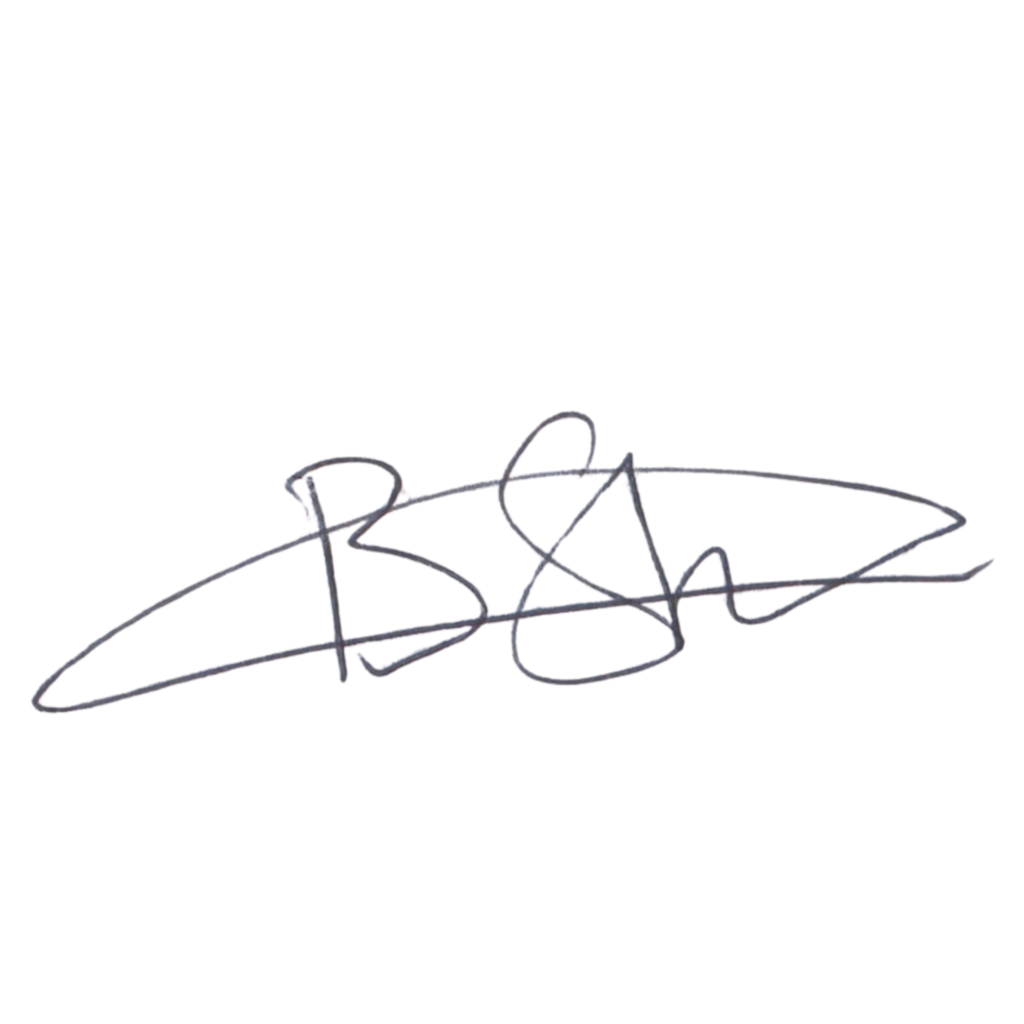  EXECUTIVE DIRECTOR  Mr. Bhekisisa Shandu  Signature:  ____________________________  Date: 6 September 2026  ____________________________ | 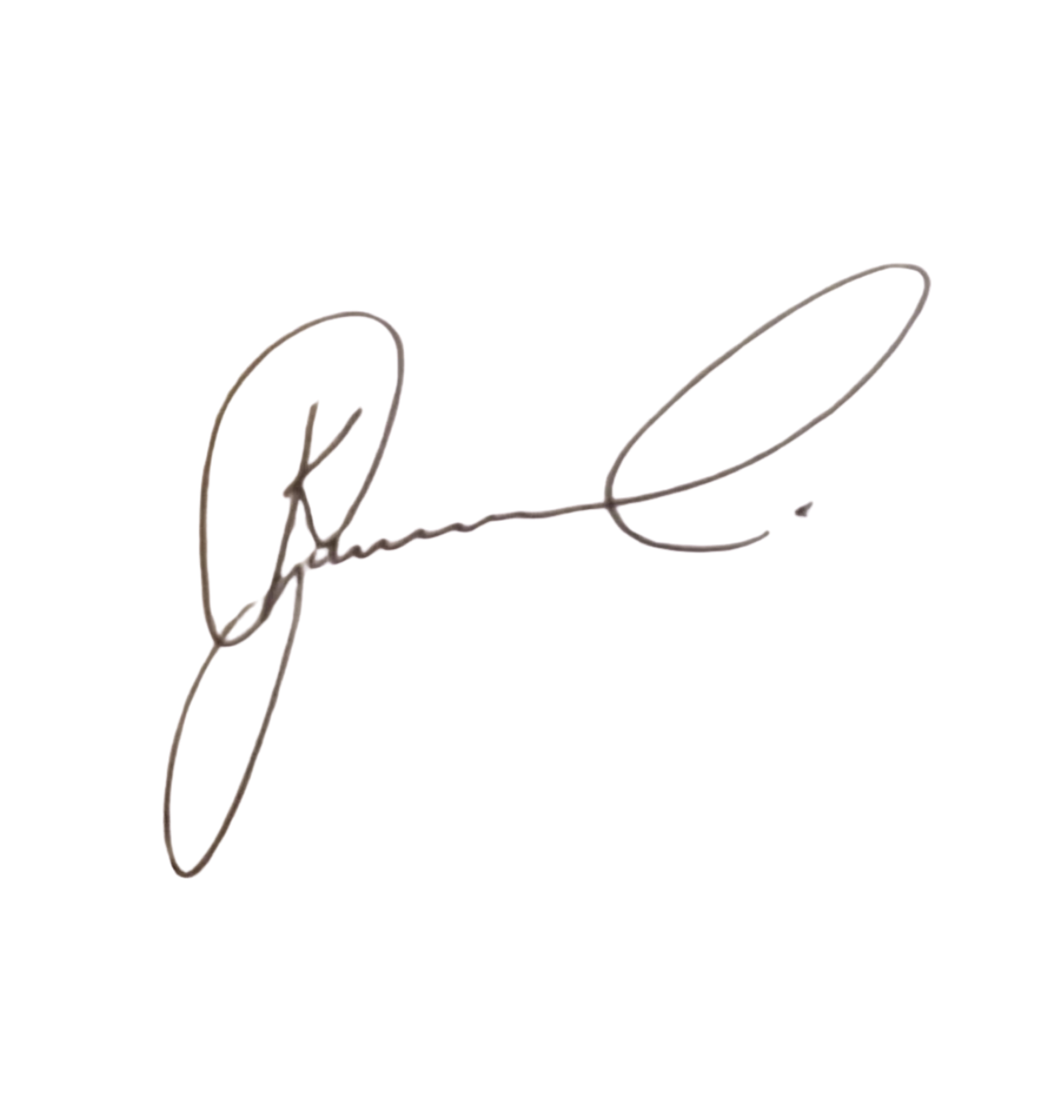  DIRECTOR: PEOPLE AND CULTURE / CHAIRPERSON: FINANCE AND PROCUREMENT COMMITTEE  Mr. Khulekani Gumede  Signature:  ____________________________  Date: 6 September 2026  ____________________________

